Course Project
Програмиране на ИТ услуги- част I
(Programming IT services)
Remote Loan Server

Acceptable Programming Languages: | Java 1.7.x
Deadline: | (for the final exam date)
Instructor | Dr. Evgeny Krustev

Problem Statement:

Develop the following RMI application.
The JFrame client application sends loan information (annual interest rate, number of years, currency code and loan amount in the respective currency code) to the server. The server reads a text file with the current exchange rates with respect to Bulgarian Leva and computes the monthly payment and total payment in Bulgarian levas, which are sent back to the client. Define a remote interface for computing monthly payment and total payment, thus allowing the server to process multiple clients in parallel. Provide support for at least 8 currency codes.
The server JFrame application should display in a textarea details for each client request and log them additionally to a file.
The JFrame client application should display client request in textfields and use a button to read the server response in a textarea inside the JFrame.
The user interface should be similar to the following:
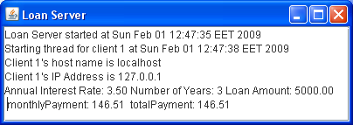
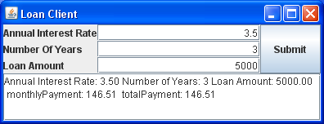
Evaluation:
Your project will be evaluated on the following general points:
- Sophistication/complexity/originality of the problem being solved/investigated and of the solution(s)/approaches considered.
- Demonstrated ability to extract/analyze concurrency-related problems/issues from a general problem/area of interest.
- Clarity of explanations, and for implementations programming skill/quality. Your report (in Bulgarian!) should be well written and free of grammatical and spelling errors. Programs must be well-commented and in a professional style.
- Awareness of related work. Others have considered the same or similar problems before you. Your work does not have to be novel, but you should be able to contextualize your approach. Be sure to explain how each referenced work is related to your work. Note that a 5-minute Google search will not be adequate; if you are unfamiliar with the required textbooks for the course:
- Completeness of the project.

Deliverables: The files with :
- the source code
- the executable code
- the instructions for compiling your source code
- the report explaining the data structures and the algorithm implementation, describe things such as how your code has been tested, limitations of your code, problems encountered, and problems remaining
- any files used to test the implementation of the program with an explanation about it included in the report.

References:
- P. Deitel, H. Deitel, "Java How to Program (early objects)", Prentice Hall 9 ed. 2012, ISBN-10: 0132575663, ISBN-13: 978-0-13-257566-9 (основна)
- Y. Daniel Liang, “Introduction to Java Programming”, 7th ed.,Prentice Hall 2009 ISBN-13: 978-0-13-601267-2
- Bruce Eckel “Thinking in Java”, 4th ed., Prentice Hall 2006
или българското й издание "Да мислим на Java" том 1 и 2, SoftPress, 2001

